RAVIRANJAN PRASAD  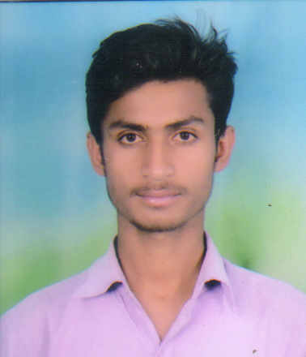  E-mail: cs16raviranjan95@gmail.com  Contact No.: +91 8503830715  Present Address:  259-A, Vaishnav Vihar,  Nangal Jaisa Bohara,  Near HVN School,  Jhothwara,  Jaipur, (Rajasthan) - 302012.  Permanent Address:  259-A, Vaishnav Vihar,  Nangal Jaisa Bohara,  Near HVN School,  Jhothwara,  Jaipur, (Rajasthan) – 302012.  Personal Profile:  Father’s Name : Mr. Tulasi Prasad  Mother’s Name: Mrs. Sunaina Devi  Date of Birth : 09-Nov-1995  Sex : Male  Marital Status : Single | Career Objective  Aspiring to work with an organization that offers responsible position where I can utilize my skills and capabilities to carve a niche for myself and effectively deliver towards contributing to the organization’s aspiration and also enhance my personal growth through continual upgrading of knowledge.  Professional Qualification:  Diploma in Computer Science & Engineering 2014-2016  Percentage – 65.92 %  Collage : Govt. Ram Chandra Khaitan Polytechnic College, Jaipur (Raj).  Board : Board of Technical Education, Rajasthan, Jodhpur (Raj).  M.A (Hindi Literature) 2018 - 2020  Board : University of Rajasthan, Jaipur(Raj).  Academic Qualification:  Sr. Secondary(Science & Mathematics) : Board Of Secondary Education, Ajmer ( Rajasthan ) with 71.60 % , 2014  Secondary : Board Of Secondary Education, Ajmer ( Rajasthan ) with 68.33 % , 2012  1 year experience of Laravel Framework(PHP) in Semidot Infotech Pvt. Ltd. Nand Puri Road Said Kemori ,Malviya Nagar Jaipur.  2 year experience of Laravel Framework(PHP) in Gempulse Infotech Pvt. Ltd. Malviya Nagar Jaipur.  6 month experience of CORE PHP developer in Websharn Infotech Pvt. Ltd. Jaipur.  1 year experience of Data Verification in NSB BPO Pvt . Ltd. Jaipur.
  Total Experience:
Computer Skills:

Programming Languages : Laravel Framework(PHP),Ajax,Jquery, Javascript,And Little bit React Js, Little bit Node Js with Express.js
Database : MySql.

Projects Details:

- https://www.sikhvivah.com/
- https://www.bizconnect.com/
- E-Prescription(Mobile Application
- https://thetraininghub.co.uk/

Strengths:

- Self Motivation.
- Self Confidence.
- Energetic.
- Hard Working.

Personal

- Hobbies - Playing Cricket, Music , Internet Surfing.
- Quality - Full of energy.
- Language Skills – Hindi & English

Declaration:

I do hereby declare that the particulars of information and facts stated herein above are true, correct and complete to the best of my knowledge and belief.

Date : __/__/2020
Place: Jaipur (RAVIRANJAN PRASAD)

